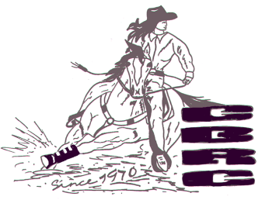
Canby Barrel Race Club
~ MEMBERSHIP FORM ~

Pee Wee Membership

Name:_________________________
Horse’s Name:____________________

Parent’s Name:________________________
Address:______________________________
Phone Number:________________________
Email:________________________________

Rider’s jacket size:______
Favorite Color:__________

PEEWEE MEMBERSHIP: Pee Wee Member: $50
Defined as 1 child rider 10 yrs of age or younger as January 1 (no adult rider). If they run in Open or Youth, they must pay Individual Membership fee and cannot go back to running in PeeWee.

________________________________________________________________________________
(Signature of Guardian) (Date)

I, the undersigned, hereby state that I have read and understand all Canby Barrel Race Club Rules and agree to abide by said rules.

